User Manual
A flight ticket booking system is a simple online booking system that handles all the information of customer as well as the flight information. This system is developed to provide customer satisfaction with great user interface. It will help to manage the flight system and also minimize the number vacant seat. This manual will assist the user for the following things:

Registration
For user to create a new account they can go to the signup page and insert the details and can create a new account to get access to the system.
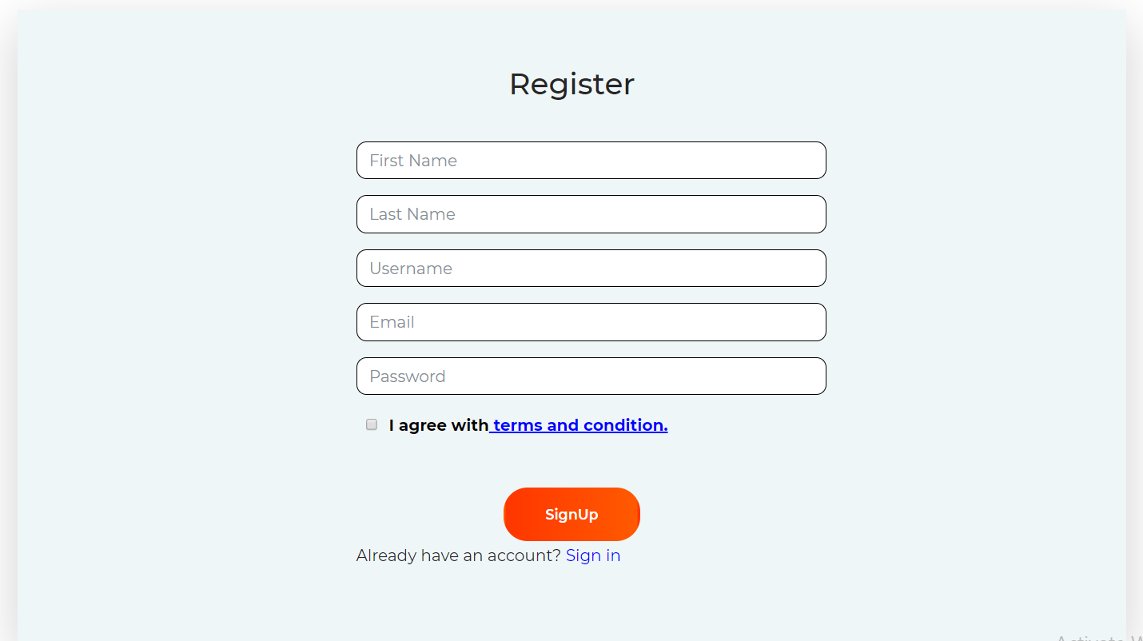

Login
By the detail of username and password user can login to the system.
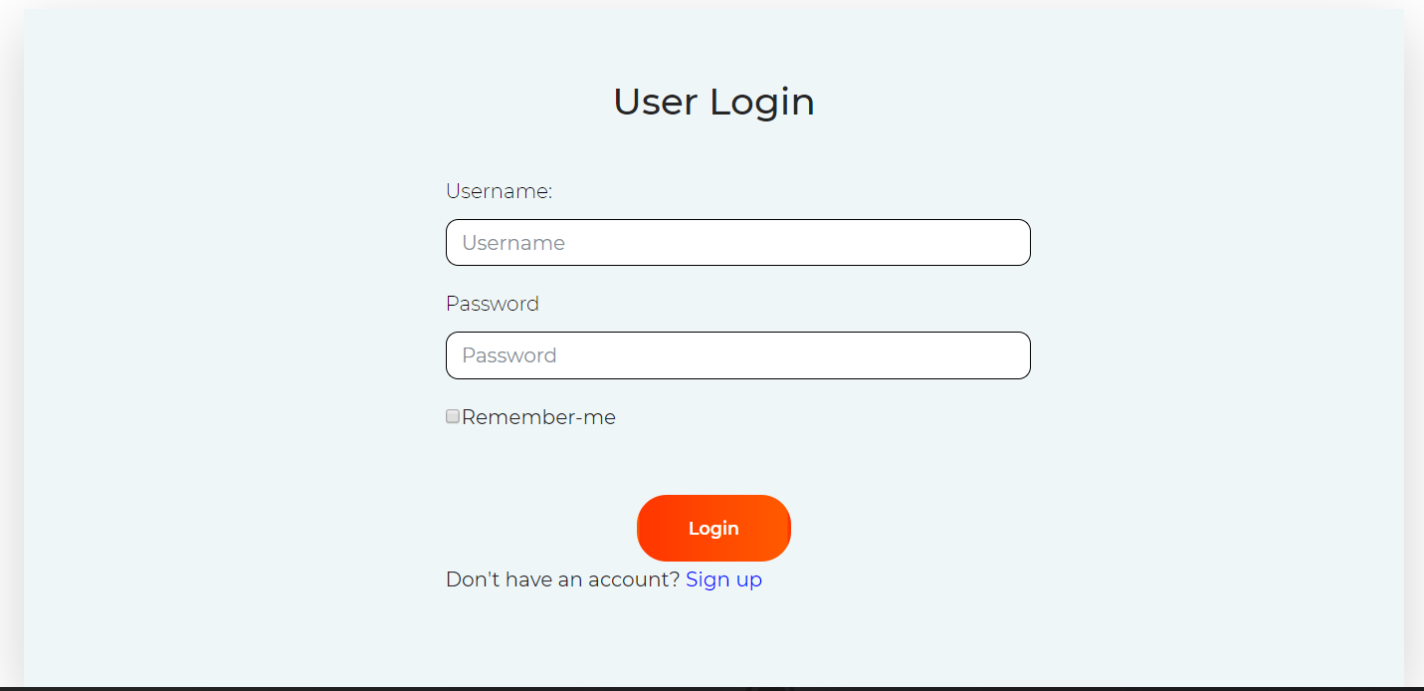

View Flight details
It is collective information of the system viewed to user. User can view all the details of flights and can also book ticket through this.
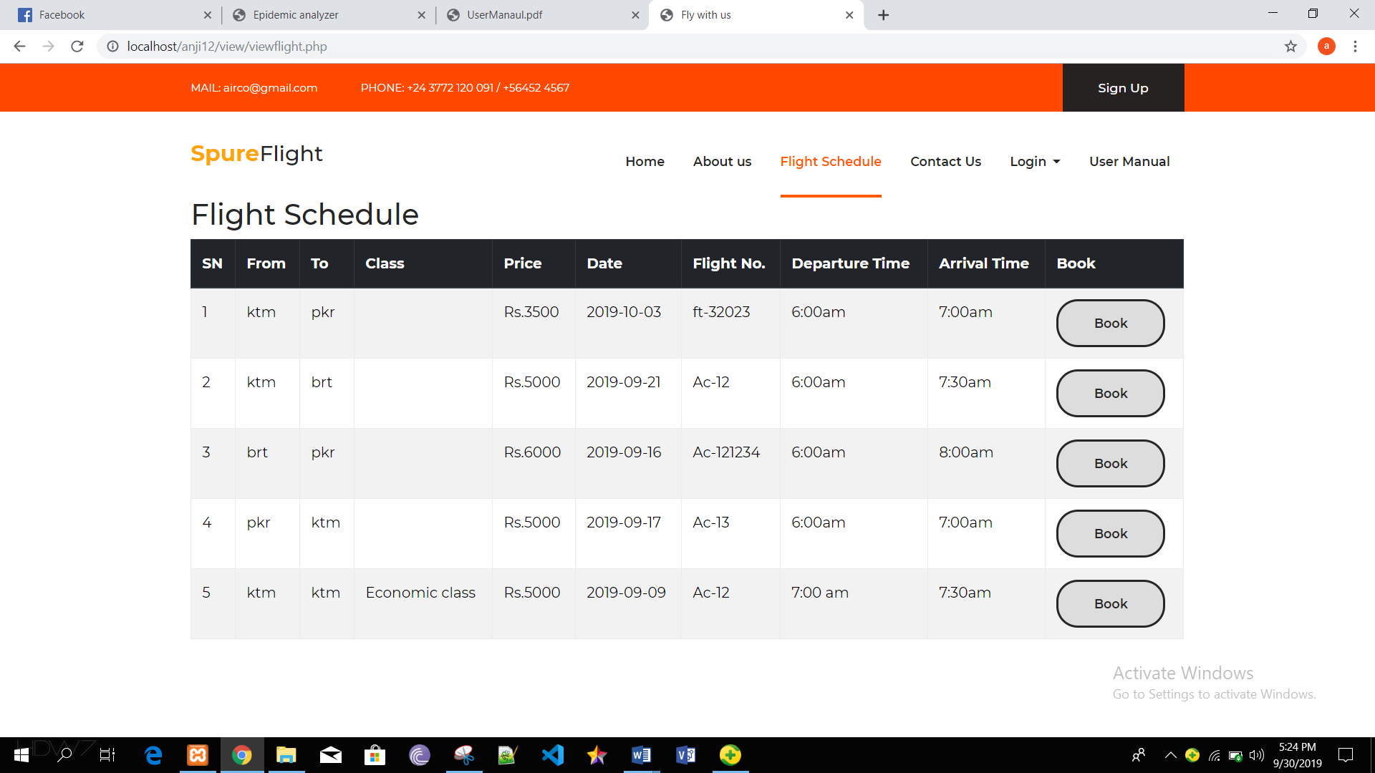

Passengers details
After booking, user have to add all the details of the passenger who is attending the flight through this.
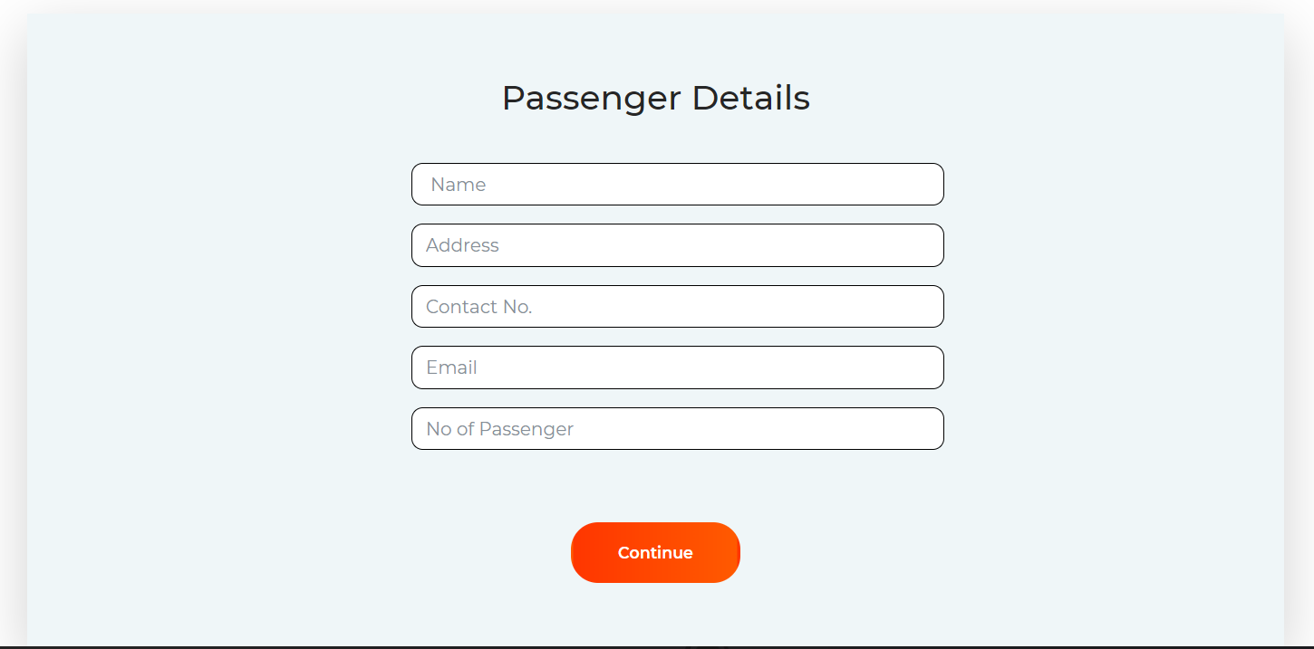

Payment method
Online payment system is available, user can add all the details of card to make payment.
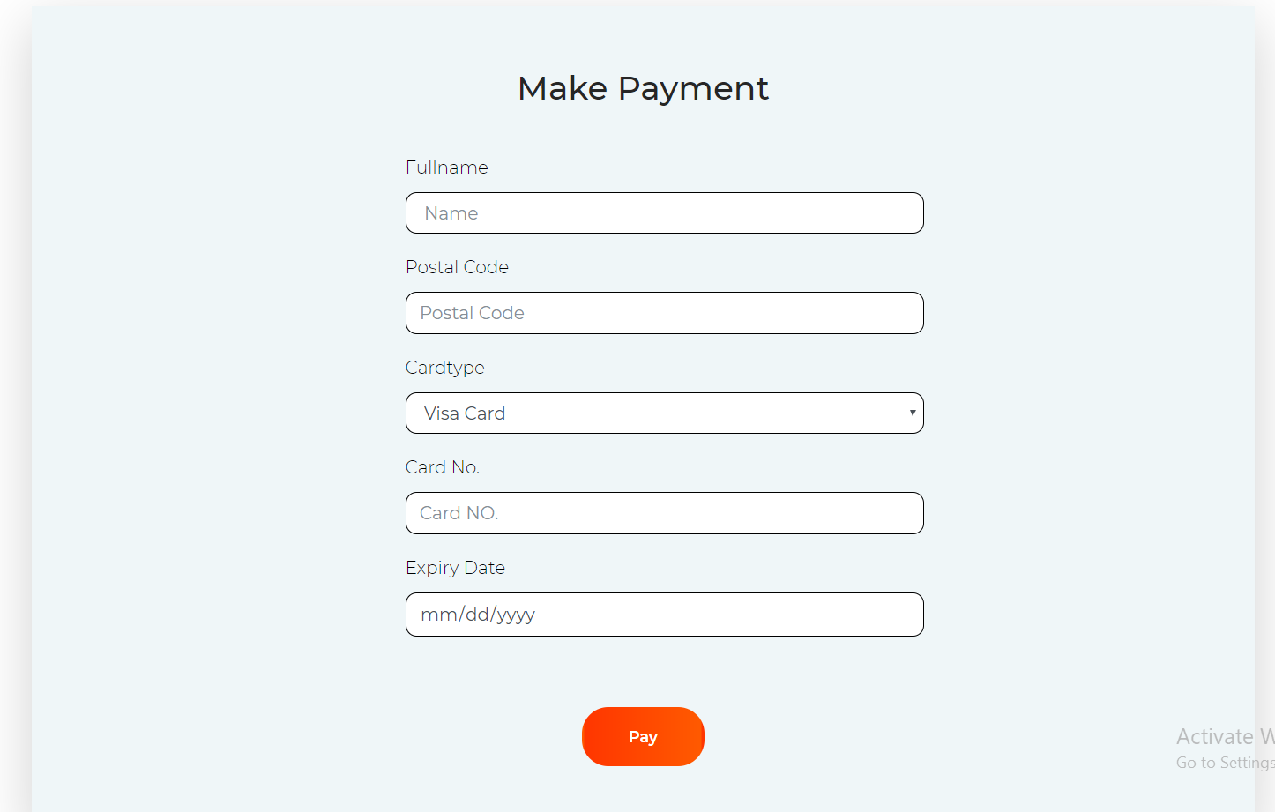

Feedback
User can send feedback to the system through this for.
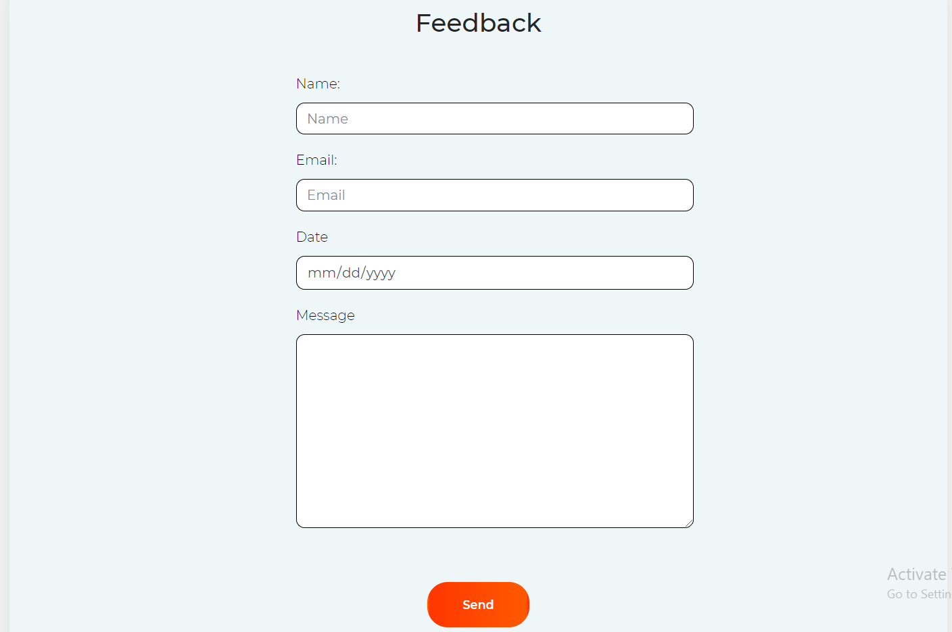

Admin login
Only admin allowed are get access to the admin panel. For this user must logged in to the system to get access to the admin dashboard.
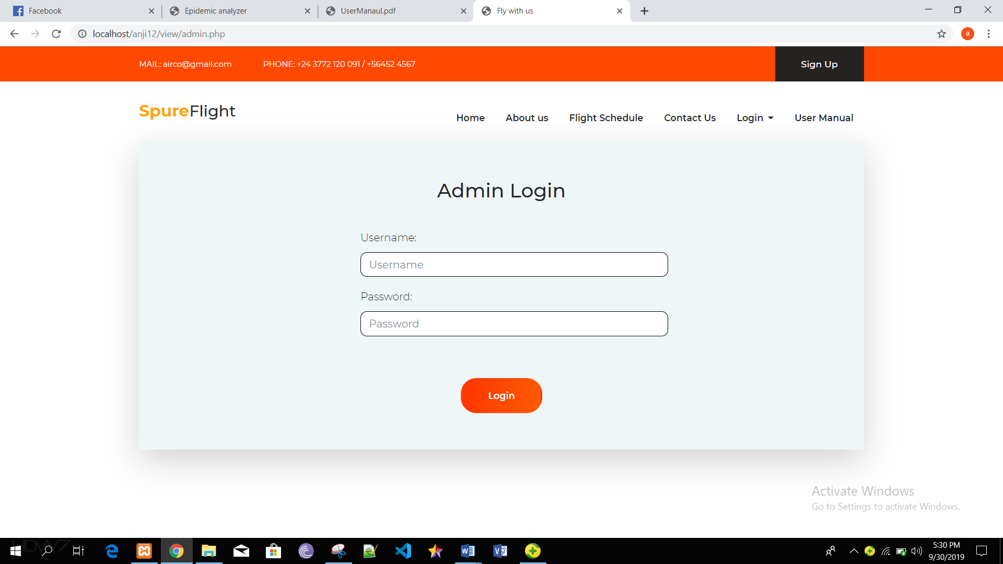

Add flight details
Admin can admin flight details through this form.
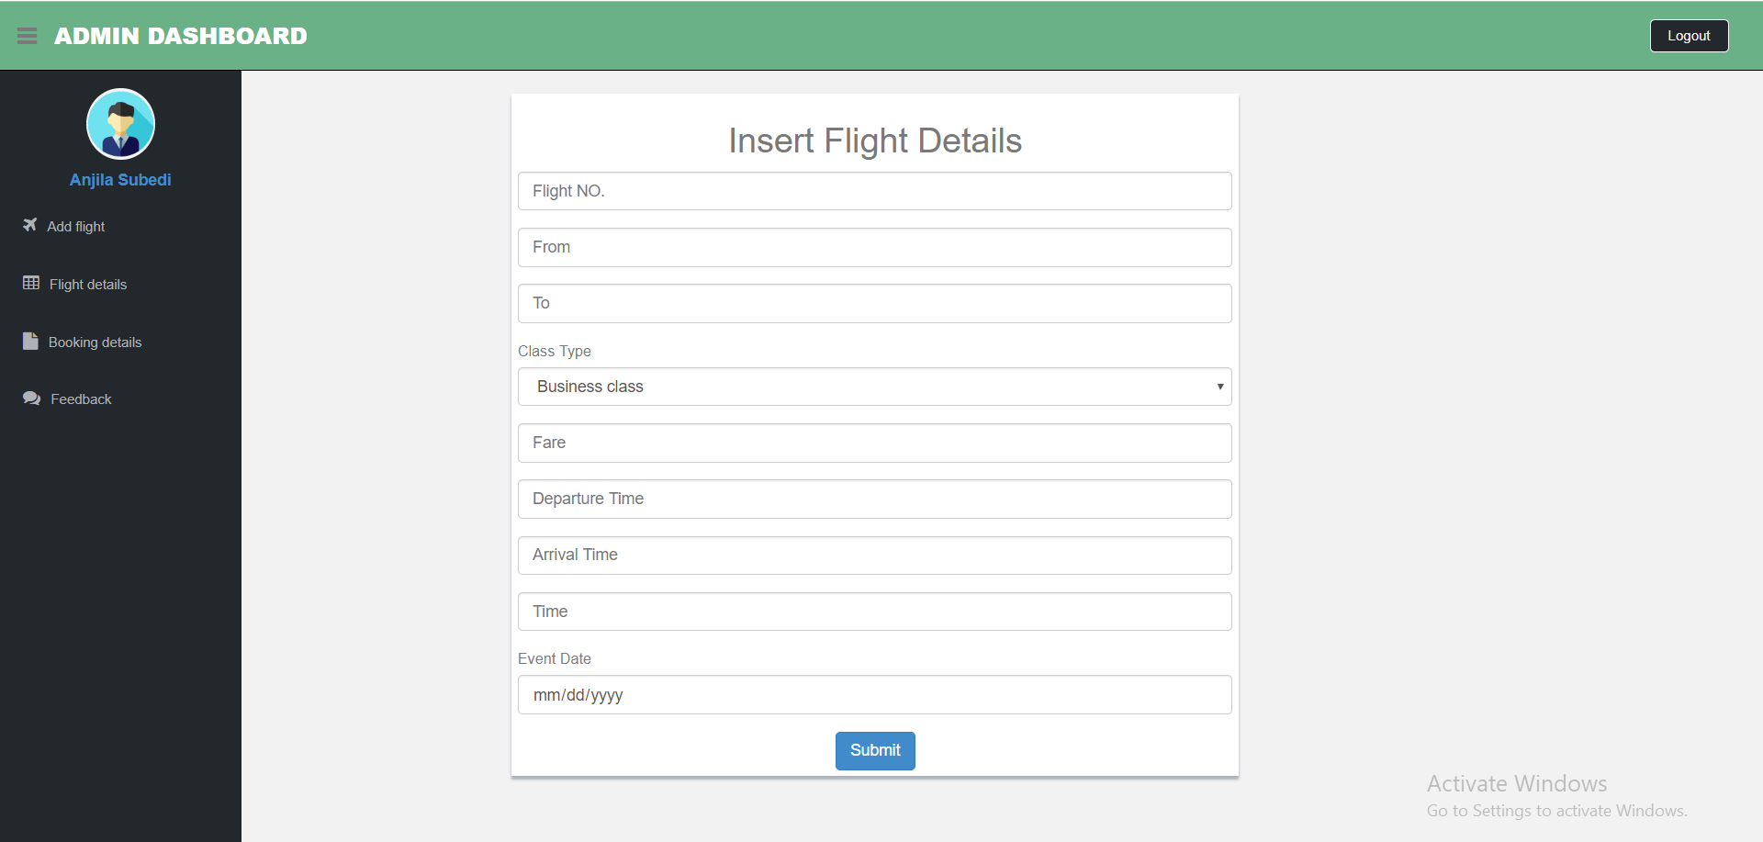

Edit and delete flight details
By clicking in the delete button, admin can delete flight details permanently.
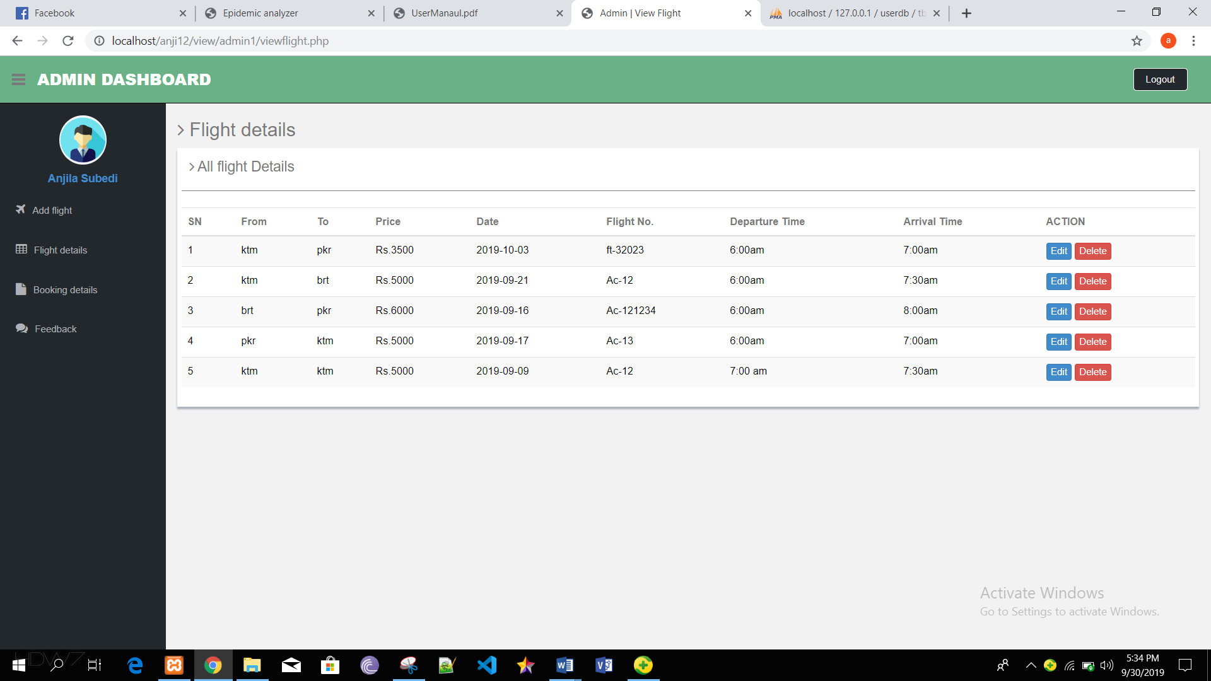

By clicking in the edit button, admin can update the flight details.
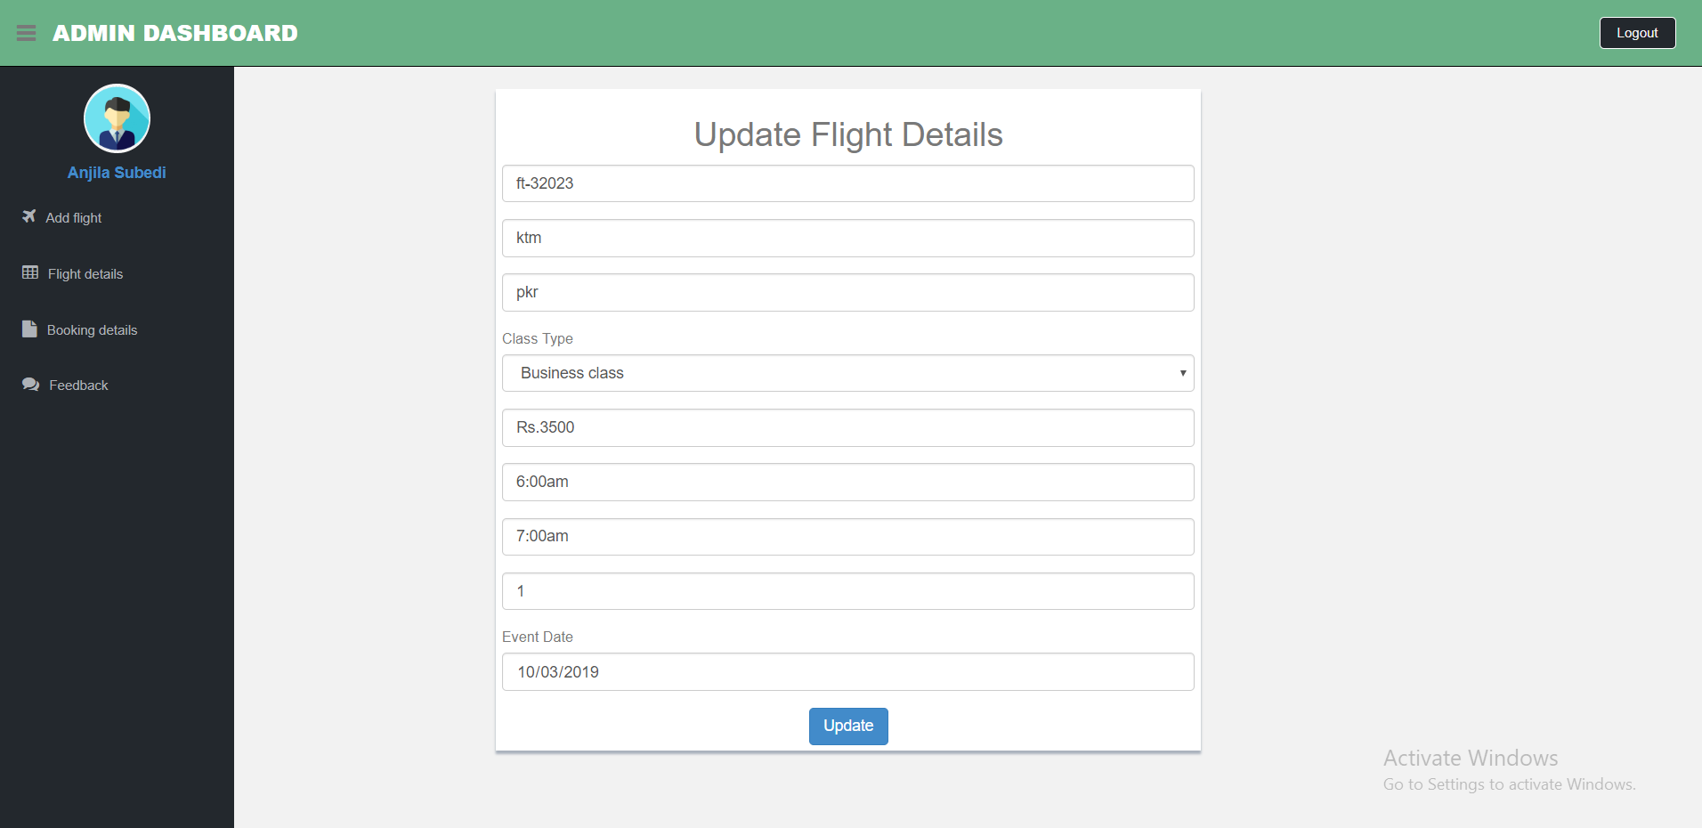

Booking details
Admin can view the number of order than delete it after transaction.
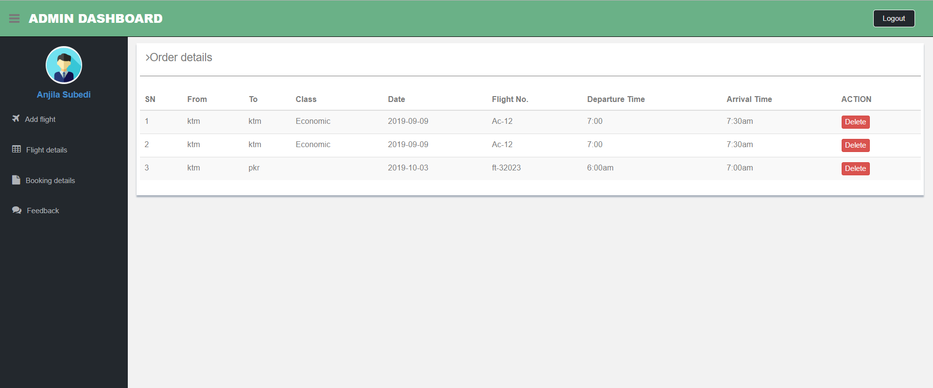

Feedback details
Admin can view all the feedback provided by the user regarding the system.
